 Ref-KSSFCL/GBB/01/2023-24 24.07.2025

SHORT TERM TENDER NOTICE FOR SUPPLY OF 2500 NOS LAPTOP BACK PACK BAGS

Sub:-Supply of 2500nos Laptop Back pack Bags for KSSFCL Bengaluru

KSSFCL Invites sealed bids on single cover system for supply of 2500nos Laptop Back pack Bags. The tenderer should be a reputed manufacturer or his authorized dealer. The detail technical specifications and configurations are given in the tender document and should be addressed to the:
The Managing Director
Karnataka State Souharda Federal Cooperative Ltd.,
#68, 18th Cross, Margosa Road, Malleswaram, Bangalore-50055.
The tender may be sent to or dropped in the Tender Box kept at above said address on or before 01th August 2025 by 3:00p.m. The bid will be opened on the same day at 4p.m. during which tenderer or its authorized representative(s) may remain present if so desired.
The terms and conditions of tender are mentioned in tender Document .KSSFCL reserves the right to cancel the tender at its sole discretion without assigning any reason at any stage.

Sd/-
(Sharanagouda G Patil)
Managing Director

Tender Document
General Information
1 | Last Date and Submission of tender | 01.08.2025 at 3.00 p.m.
2 | Date and time of Opening Tender | 01.08.2025 4:00PM.
3 | Tender Document Fee | Rs. 1,000/-+ 18% GST
4 | EMD Amount | Rs. 15,000/-
5 | Place of Opening of Tender | KSSFCL  #68, 18th -17th Cross , Margosa Road, Malleswaram,Bangalore-50055.

ABOUT THE KSSFCL
Karnataka State Souharda Federal Cooperative Ltd, the first Apex Body of New generation cooperatives in India. Souharda Federal Cooperative is a quesi judicial and democratically elected self-regulatory organization of the cooperatives registered under Karnataka Souharda Sahakari Act, 1997.

(B)TERMS & CONDITIONS:-
  - The price will be inclusive of all freight / handling charge. No extra charges will be paid. GST No. and Charges must be mentioned in your quotation, otherwise it may consider as rates are inclusive of GST.
  - Work may be awarded to lowest rate quoted by agency (L-1 basis) .
  - Final payment shall be on the basis of actual rate quoted in below table.
  - Price validity shall be 60 days from the date of opening.
  - reputed manufacturer or his authorized dealer submitting the proposal must registered under GST and GSTN and PAN shall be submitted by the agency/Contractor with the proposal.
  - Guarantee/Warranty shall be covered by OEM and guarantee/warrantee documents to be submitted with invoice.
  - Bidders have to submit the Authorization letter for selling of Laptop Back pack Bags
  - Bids received without prescribed Earnest Money Deposit (EMD) and required documents shall not be considered.
  - Bidder have to submit the non-blacklisting declaration in the format(Annexure-A).
  - One sample bag should be submitted along with tender.

(C )MODE OF SUBMISSION
    - Tenders should be addressed to Managing Director, KSSFCL, and Bengaluru only.
    - Tender can be submitted in person on or before the due date and time specified in the tender notice. Such tenders may be dropped in the TENDER BOX kept at the reception/common area of KSSFCL Bengaluru.
    - Alternatively, the tenderer who prefers to submit the tender through post can dispatch the same through Registered Post or Courier so as to reach the above address on or before the due date and times pecified in the Tender Notice. Tenders received after the due date and time, for whatsoever reasons will not be considered, and the KSSFCL, will not be liable or responsible for the same.
    - Tender should be submitted in the prescribed Tender Document obtained from, KSSFCL Bengaluru or downloaded from KSSFCL website.
  - EARNEST MONEY DEPOSIT & SECURITYDEPOSIT
    - Tenderer shall enclose a demand draft/pay order of any scheduled bank of Rs.15,000/- (Twenty Thousand only) in favor of Karnataka state Souharda Federal cooperative ltd payable at Bengaluru as the non-interest bearing Earnest Money Deposit. Bid without EMD shall be rejected.
    - The Earnest Money Deposit of the unsuccessful tenders will be returned, after the acceptance of the work order by successful tender,at the expense of the Tenderer with in reasonable time. Earnest Money Deposit will not bare any interest there on.
    - Cheque, Bank Guarantees will not be accepted towards EMD.
    - The Earnest Money Deposit/Security Deposit will be forfeited if:
- Successful bidder fail to supply the Laptop Back pack Bags
- Tenderer with draw his tender or backs out after submission of tender
- Tenderer fails to remit the Security Deposit @05% of supply order value.
  - DELIVERY:The successful bidder should supply the Laptop Back pack Bags with in 10 days from the date of “Purchase Order”.
  - PAYMENT TERMS: 100% payments shall be made after the successful safe delivery, of the order.
  - JURISDICTION FOR LEGAL PROCEEDING: Suit or any legal proceedings in this regard to this matter arising in any respect under this contract shall be instituted in any court in Bengaluru only.
  - PENALTY: In the event of failure of the successful tenderer to make supply of Laptop Back pack Bags with in the stipulated time, without prejudice too their remedies under the contract a penalty equivalent to 0.5% (Half Percent) of the value of delayed goods will be levied per week with a maximum of 5% of the contract value. If requested by the tenderer, it is the discretion of the, KSSFCL Bengaluru to grant extension of time with penalty/ without penalty and to purchase the stock from any other source at the prevailing market rate at the risk and responsibility of the successful tenderer and to claim any loss sustained by KSSFCL Bengaluru in the transaction from the tenderer be sides forfeiting Earnest Money Deposit and Security Deposit.
Signature Manufacturer or his authorized dealer
(Full signature of theTenderer with seal of the dealer)

Date:24.07.2025
Place:Bangalore

Annexure ‘A’

UNDERTAKING

1/We ..................................................………………………………………..
(local address Permanent address) solemnly state that I/We have not so far been black listed by any of the institutions/offices in which I/We have worked/working.

Signature Manufacturer or his authorized dealer
(Full signature of the Tenderer with seal of the Agency)

Date:

Place:

Annexure ‘B'
PRICE BID
Supply of 2500 Qty Laptop Back pack Bags for KSSFCL Bangalore

Sl.No | Details scope of the works- |  | Amount including all taxed and charges
01 | Laptop Back Pack Bags with Office name Printing | 2500
*Total (Amount in word).............. ......... .... ... ............ ................................. ..... ...................................

Signature Manufacturer or his authorized dealer
(Full signature of the Tenderer with seal of the dealer)

Annexure ‘C'

Laptop Back pack Bags Specification:
Style | Customized
Brand | Customized Bag
Material | Spl Original Darshan Chord Maty Nylon
Colour | Blue and Black
Size of the bag & compartment | Height 18*12 inch width, border 9.5 inch and with 4 compartment.
Laptop pouch | Separated with thick Rainwear lining and a laptop pouch with padded and a velvet strap.
Zips and Finishing | All the Zips Should be of no 10 size (Big) imported heavy quality, with steel sun slider and bottom should have a bubble pad with extra thin padding.
Sample Image -front  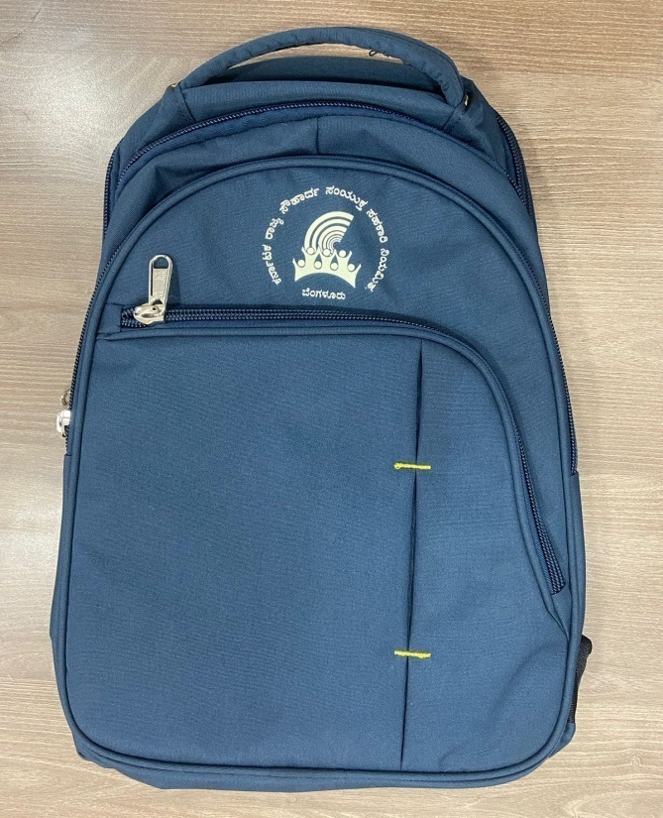 | Sample Image -Back  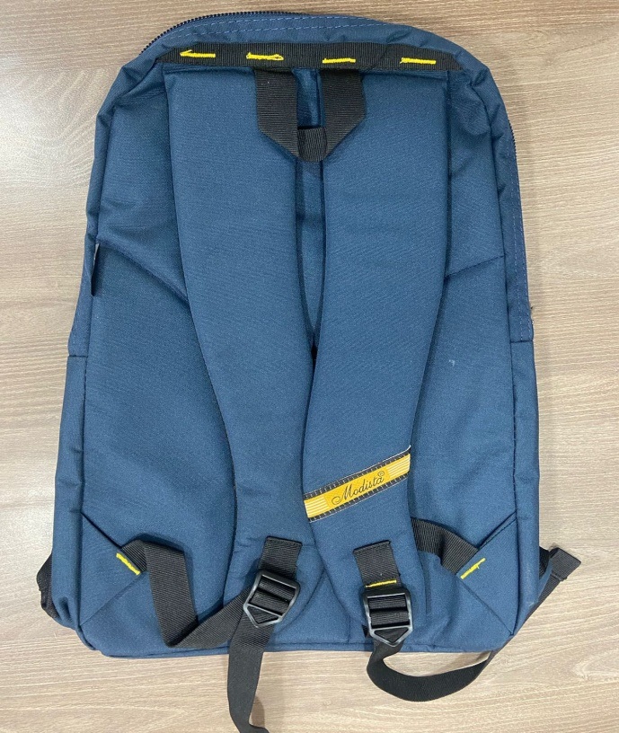

Signature of contractor
(Full signature of the Tenderer with seal of the dealer)

