AIR CONDITIONING
DESIGN BASIS REPORT

AIR CONDITIONING FOR OFFICE BUILDING,

BASIS OF DESIGN FOR NEW AIR CONDITIONING SYSTEM

CODES AND STANDARDS:
Apart from the specific equipment standards and specifications, the following broad certifying agency / standards have been considered while designing the system in accordance with the Thermodynamic Principles.
- ASHRAE Standards

- ASHRAE : 90.1 – Energy Standard for Buildings Except Low – Rise Residential Buildings

- ISHRAE : Weather Data

- ARI : Cooling Coil ratings

DESIGN PARAMETERS
OUTDOOR DESIGN DATA:
CITY NAME …………… BANGALORE
LOCATION ……………………………………. INDIA
LATITUDE ……………………………………. 12.58° N.
ELEVATION ……………………………………… 3020 FT
SUMMER DESIGN DRY-BULB………………… 96.0°F
SUMMER COINCIDENT WET-BULB…………… 78.0°F
RELATIVE HUMIDITY …………………………… 45.0 %
SUMMER DAILY RANGE………………………… 22.0 °F
MONSOON DESIGN DRY-BULB………………… 82.0 °F
MONSOON COINCIDENT WET-BULB…………… 78.0 °F
RELATIVE HUMIDITY ……………………………… 82.0 %
WINTER DESIGN DRY-BULB……………………… 58.0 °F
WINTER DESIGN WET-BULB……………………… 54.0 °F
RELATIVE HUMIDITY ……………………………… 78.0 %

INSIDE DESIGN CONDITIONS:
The Indoor Temperature to be maintained is as follows:
TEMPERATURE : 72ºF ± 1.8 ºF (22 ºC ± 1ºC)
RELATIVE HUMIDITY : 55+/-5 % considered only for
Calculation Purpose (* Variable)

ESTIMATed COOLING LOAD:
Cooling load is about 54.5TR as assessed using computer programme based on ASHRAE / ISHRAE methodology.

proposed air conditioning SYSTEM DESCRIPTION

RECOMMENDATION: It is recommended to install multiple units of DUCTABLE Type Air conditioning System, CASSETTE TYPE & HI WALL TYPE SPLIT AIR CONDITIONER SYSTEMS.
The air conditioning system shall comprise of Air-cooled Condensers Having Scroll type Compressors condensing unit The Refrigerant used will be R22

.

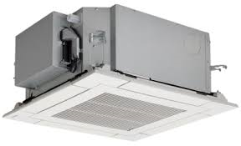
CASETTE TYPE INDOOR UNIT
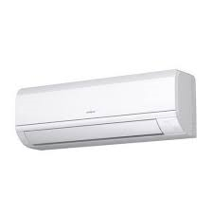
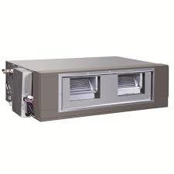
HI WALL TYPE SPLIT AIR CONDITIONER

DUCTABLE TYPE SPLIT AIR CONDITIONER

